
project report
Submitted By : KARTIK || Registration no. : 25BAI11154

March 28, 2026
COURSE : fundamental of aiml
COURSE CODE : 2001

TITLE : SENTIMENT DETECTOR

INTRODUCTION:
A Sentiment Detector is an Artificial Intelligence system designed to analyse and interpret human emotions expressed in text. It falls under the domain of Natural Language Processing (NLP), where machines are trained to understand, process, and derive meaning from human language.

WHAT DOES IT DO :
The core objective of a sentiment detector is to classify text into emotional categories such as:
- Positive 😊 (e.g., “I love this product!”)
- Negative 😠 (e.g., “This service is terrible.”)
- Neutral 😐 (e.g., “The meeting is at 5 PM.”)
More advanced systems can detect:
- Emotions like joy, anger, sadness, fear
- Sarcasm or mixed sentiment
- Intensity of feelings (e.g., mildly happy vs extremely happy)
MOTIVATION OF THE PROJECT:
The motivation for building a Sentiment Detector stems from the growing need to understand human opinions at scale in a digital world dominated by text data.

Humans naturally express emotions through words, but machines traditionally struggle with this. Using Natural Language Processing, this project aims to:
- Bridge the gap between human language and machine understanding .
- Enable systems to interpret tone, mood, and intent.
Modern AI systems (like chatbots and assistants) need to be emotionally aware. Without sentiment detection:
- Responses can feel robotic
- User experience suffers
- This project enables AI to respond more intelligently and empathetically.

PROBLEM STATEMENT :
Develop an AI-based system that can automatically analyse and classify textual data into sentiment categories (such as positive, negative, or neutral) with high accuracy, overcoming challenges like ambiguity, context sensitivity, and linguistic variations.

OBJECTIVE OF THE PROJECT :
The objective of a Sentiment Detector project is to design and implement an intelligent system that can automatically identify and classify emotions expressed in text data using techniques from Natural Language Processing.

  - 📥 Text Data Processing
  - 🔍 Feature Extraction
  - 🤖 Model Development
  - 📊 Sentiment Classification
  - 📈 Performance Evaluation
  - ⚡ Automation of Analysis

EXISTING METHOD :
- Lexicon-Based Approach:
- This method uses a predefined dictionary (lexicon) of words where each word has a sentiment score.

Advantages:
- Simple to implement
- No training data required
- Fast execution

Limitations:
- Cannot understand context
- Fails with sarcasm (e.g., “Great, just what I needed 🙄”)
- Limited vocabulary

- Machine Learning-Based Approach :
- Uses supervised learning algorithms trained on labeled datasets.

Advantages:
- Better accuracy than lexicon methods
- Learns from data
- Handles variation in language

Limitations:
- Requires labeled dataset
- Performance depends on data quality
- Cannot fully understand deep context

- Deep Learning-Based Approach :
- Uses neural networks to understand context and sequence in text.

Advantages:
- High accuracy
- Understands context better
- Handles complex language

Limitations:
- Requires large datasets
- High computational cost
- Complex to implement

- Hybrid Approach :
- Combines lexicon + machine learning or ML + deep learning

Advantages:
- Improved accuracy
- Balanced performance

Limitations:
- More complex system design

METHODOLOGY:
The methodology defines the step-by-step workflow used to design and implement the sentiment detection system using concepts from Natural Language Processing.

Step 1: Data Collection
- Gather text data such as:
  - Product reviews
  - Social media comments
  - Feedback datasets
- Data is usually stored in CSV or JSON format

🔹 Step 2: Data Preprocessing
- Clean and prepare the text:
  - Remove punctuation, special characters
  - Convert text to lowercase
  - Remove stopwords (e.g., “is”, “the”, “and”)
  - Tokenization (splitting text into words)

🔹 Step 3: Feature Extraction
- Convert text into numerical form so machines can understand it:
  - Bag of Words
  - TF-IDF
  - Word embeddings

🔹 Step 4: Model Selection & Training
- Use machine learning algorithms in Python:
  - Naive Bayes
  - Logistic Regression
  - Support Vector Machine
- Train the model on labeled data (positive/negative/neutral)

🔹 Step 5: Model Evaluation
- Test the model using metrics:
  - Accuracy
  - Precision
  - Recall
  - F1-score
- Improve performance by tuning parameters or increasing dataset

🔹 Step 6: Prediction / Deployment
- Input new text → Model predicts sentiment
- Integrate into:
  - Web app
  - Chatbot
  - CLI tool
GOAL :
🔹 Primary Goal
To build an intelligent system that can automatically detect and classify the sentiment of text with high accuracy.

🔹 Secondary Goals
- 🧠 Enable machines to understand human emotions in text
- ⚡ Automate large-scale text analysis
- 📊 Provide meaningful insights from unstructured data
- 🤖 Improve user interaction in AI systems (chatbots, assistants)

FUNCTIONAL MODULES DESIGN AND ANALYSIS :
The system is divided into independent modules, each responsible for a specific function. This modular architecture improves maintainability, scalability, and clarity.

1. Data Input Module
Function:
- Accepts input text from:
  - Dataset files (CSV/JSON)
  - User input (CLI/Web interface)
Analysis:
- Must support multiple formats
- Should validate input to avoid errors

2. Data Preprocessing Module
Function:
- Cleans and prepares raw text:
  - Lowercasing
  - Removing punctuation & stopwords
  - Tokenization
Analysis:
- Critical for improving model accuracy
- Poor preprocessing leads to noisy data and weak predictions
- Uses tools like NLTK or spaCy

3. Feature Extraction Module
Function:
- Converts text into numerical vectors:
  - Bag of Words
  - TF-IDF
Analysis:
- Determines how well the model understands text
- Trade-off between simplicity (BoW) and context awareness (embeddings)
- Often implemented using scikit-learn

🔹 4. Model Training Module
Function:
- Trains machine learning model on labeled data
Algorithms Used:
- Naive Bayes
- Logistic Regression
Analysis:
- Core intelligence of the system
- Requires balanced and sufficient dataset
- Built using Python libraries

5. Model Evaluation Module
Function:
- Measures performance using:
  - Accuracy
  - Precision
  - Recall
  - F1-score
Analysis:
- Helps identify overfitting/underfitting
- Ensures reliability before deployment

6. Prediction Module
Function:
- Takes new input text
- Outputs sentiment (Positive / Negative / Neutral)
Analysis:
- Must be fast and responsive
- Should handle unseen data effectively

7. User Interface Module
Function:
- Provides interaction via:
  - CLI (Command Line Interface)
  - Web UI
Analysis:
- Improves usability
- Not mandatory but adds practical value

ALGORITHM DEVELOPMENT :

The algorithm defines the logical step-by-step procedure used to build and run the sentiment detection system using techniques from Natural Language Processing.

- Training Phase Algorithm
This phase builds the model using labeled data.
🔹 Algorithm Steps
- Start
- Load Dataset
  - Import dataset (CSV/JSON) containing text and sentiment labels
- Preprocess Text Data
  - Convert text to lowercase
  - Remove punctuation and special characters
  - Remove stopwords
  - Perform tokenization
- Split Dataset
  - Divide into training set and testing set
- Feature Extraction
  - Convert text into numerical vectors using:
    - TF-IDF or Bag of Words
- Model Selection
  - Choose algorithm (e.g., Naive Bayes / Logistic Regression)
- Train Model
  - Fit model on training data
- Evaluate Model
  - Predict on test data
  - Calculate accuracy, precision, recall, F1-score
- Save Model
  - Store trained model for future predictions
- End

- Prediction Phase Algorithm
This phase is used when the system is already trained.
🔹 Algorithm Steps
- Start
- Input Text
  - Accept user input (sentence/review)
- Preprocess Input
  - Apply same cleaning steps as training
- Transform Input
  - Convert text into vector using trained feature extractor
- Load Trained Model

- Predict Sentiment
  - Use model to classify sentiment
- Display Output
  - Show result: Positive / Negative / Neutral
- End

SOFTWARE ARCHITECTURAL DIAGRAM:

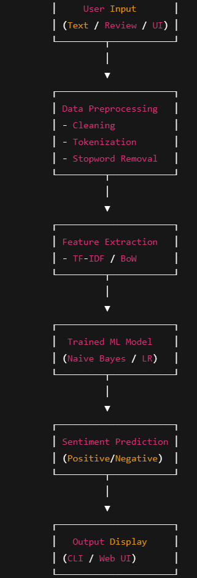
CODING :
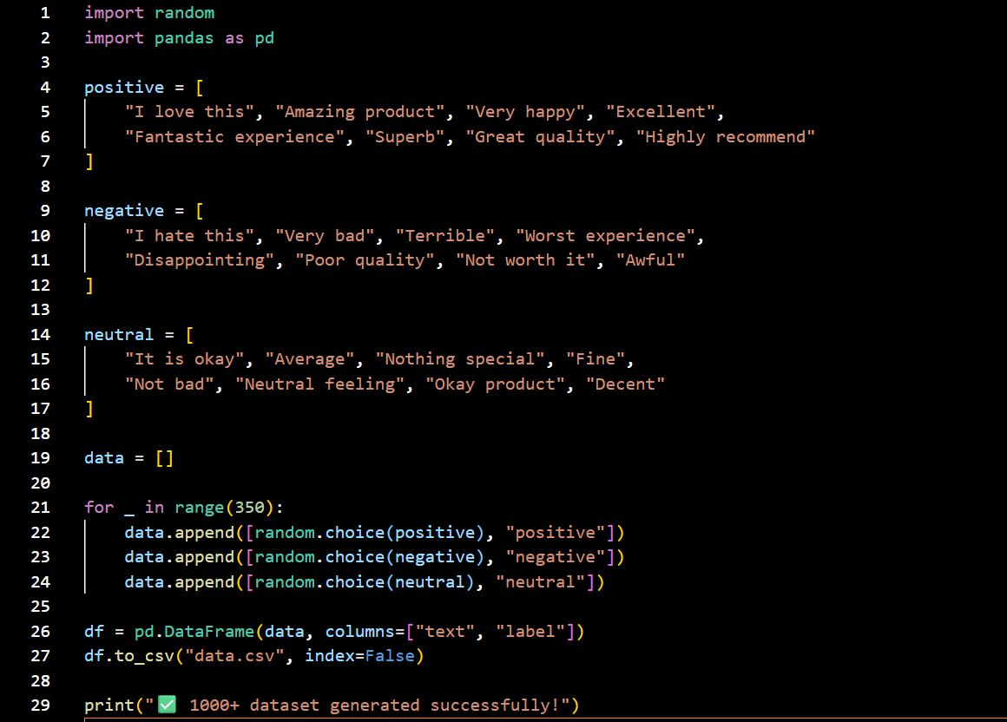
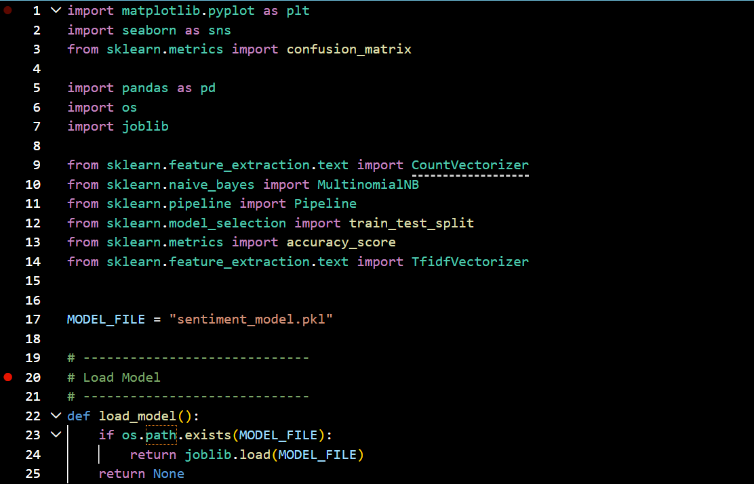
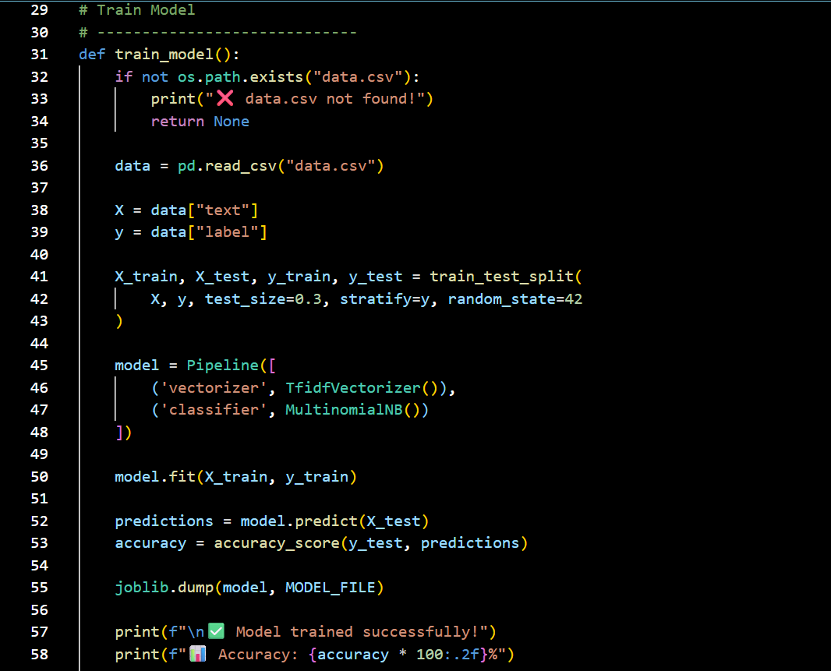
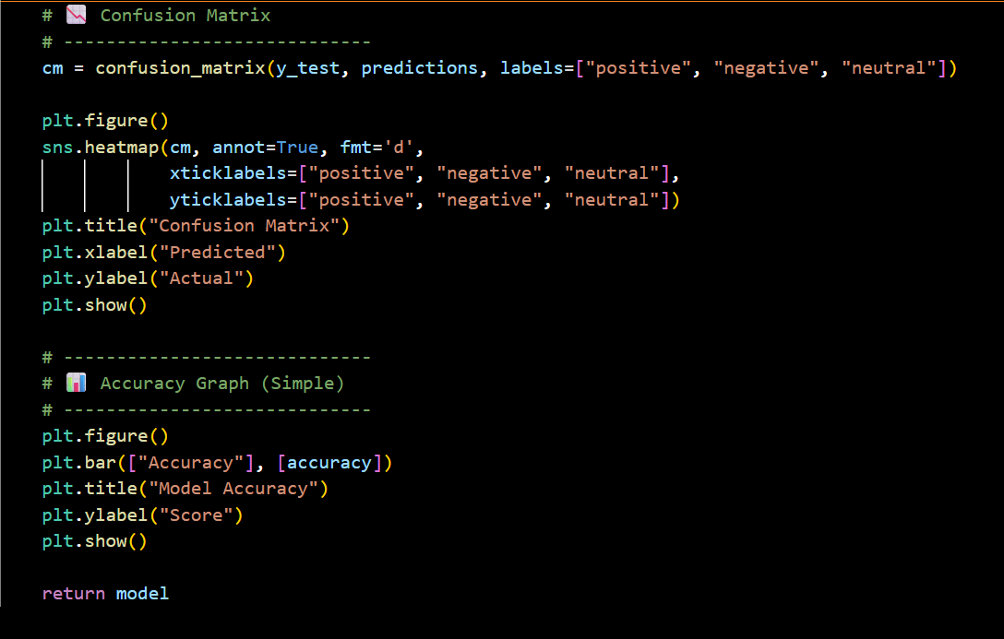
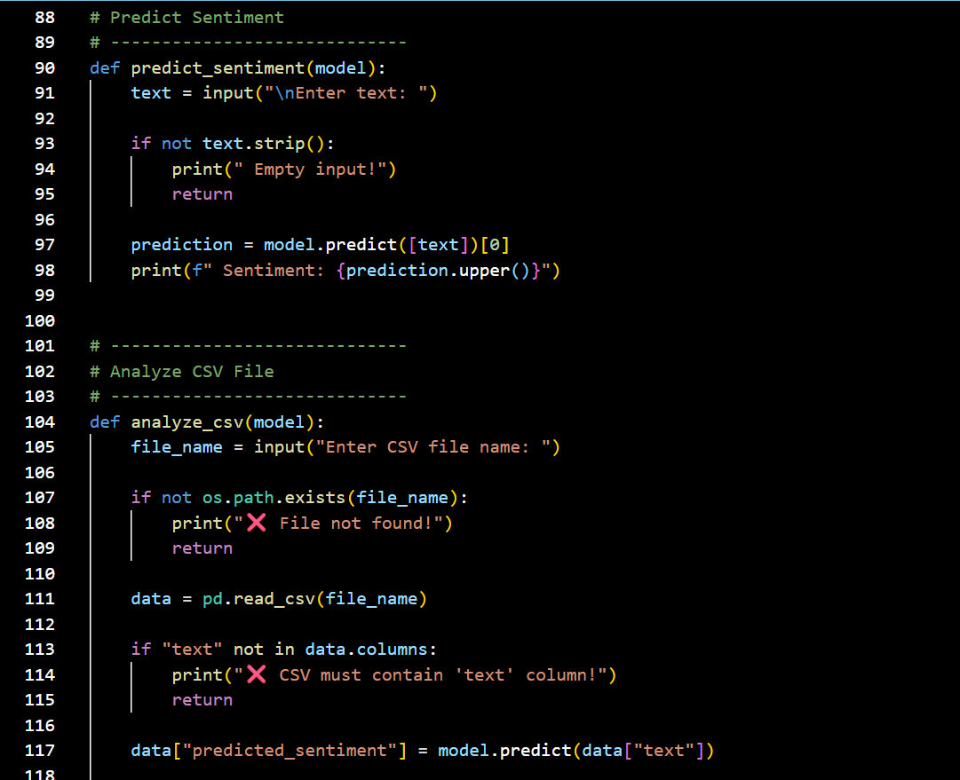
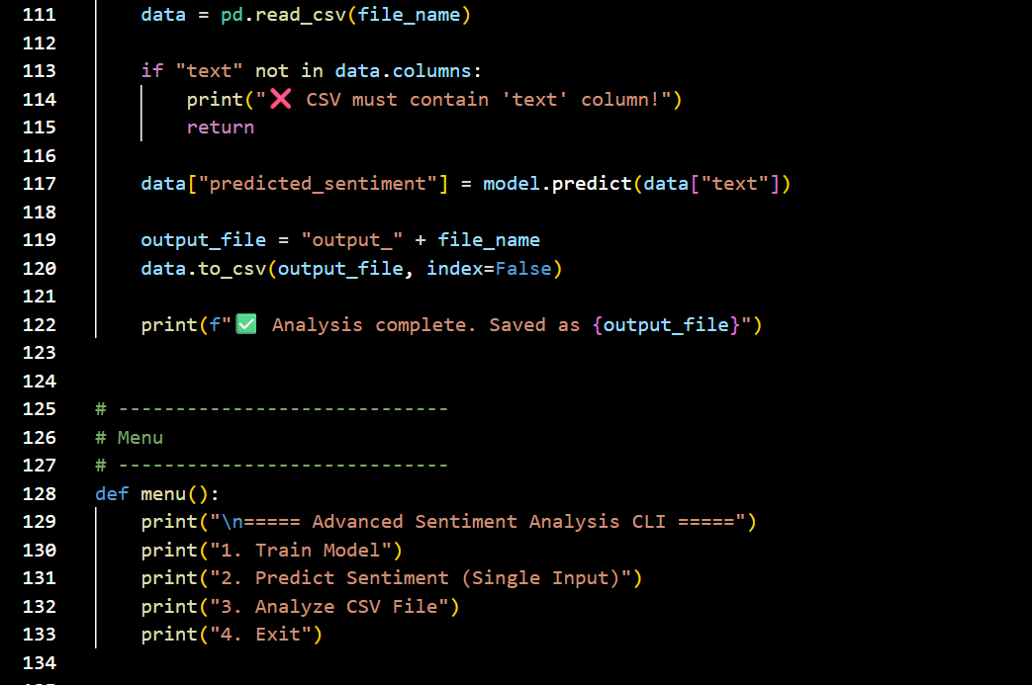
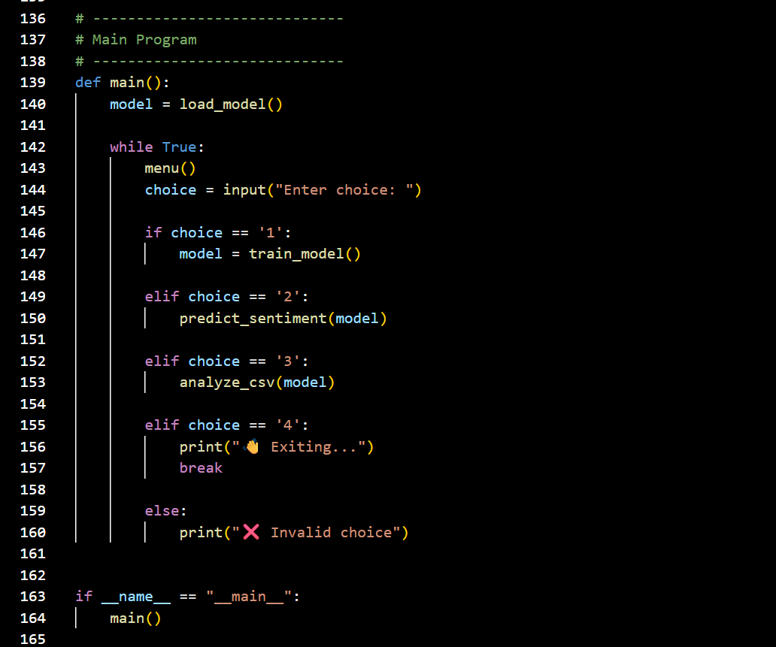

OUTPUT:
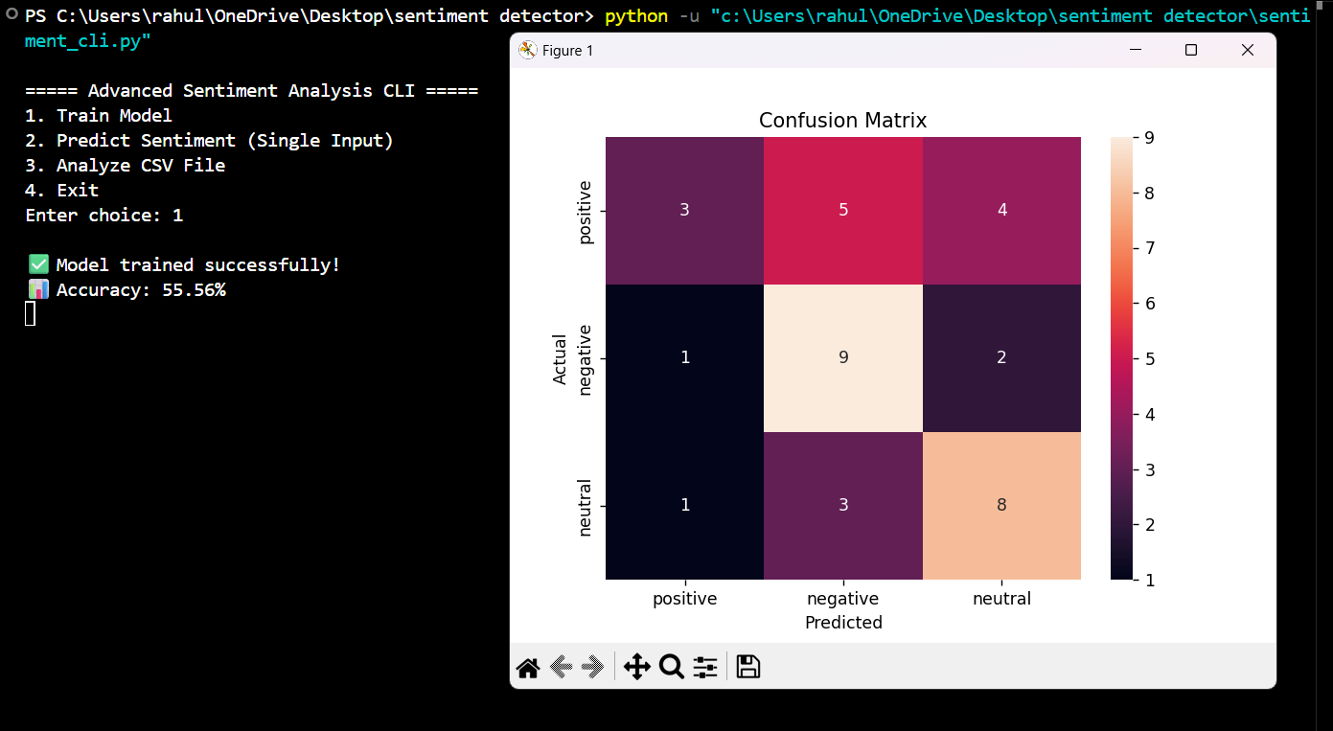
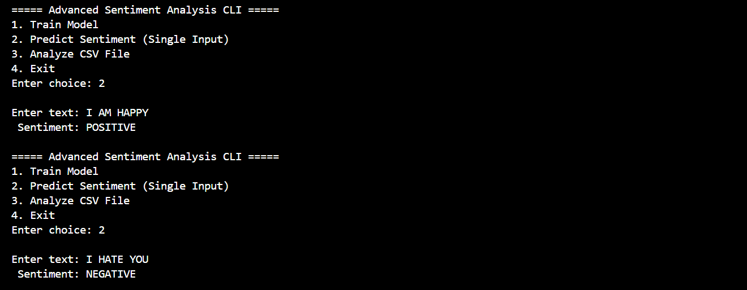

CONCLUSION :
The Sentiment Detector AI Project successfully demonstrates how machines can be trained to understand and classify human emotions expressed in text using techniques from Natural Language Processing.

- Key Outcomes
- Developed a system capable of classifying text into:
  - Positive 😊
  - Negative 😠
  - Neutral 😐
- Automated the analysis of large volumes of textual data
- Reduced manual effort and improved efficiency
- Achieved reliable performance using machine learning models

- Learning & Implementation
Through this project, important concepts were applied, such as:
- Text preprocessing and cleaning
- Feature extraction techniques (TF-IDF, Bag of Words)
- Model training and evaluation using Python
- Performance measurement using accuracy, precision, recall, and F1-score

- Limitations
- Difficulty in detecting sarcasm and complex emotions
- Accuracy depends heavily on dataset quality
- Basic models may lack deep contextual understanding

FUTURE ENHANCEMENT :
- Integration with deep learning models (LSTM, Transformers)
- Use of larger and more diverse datasets
- Real-time sentiment analysis in applications like chatbots and social media monitoring
- Multilingual sentiment detection

REFERENCE :
- Books
- Speech and Language Processing – by Daniel Jurafsky and James H. Martin
  - A fundamental book for understanding NLP concepts and sentiment analysis
- Natural Language Processing with Python – by Steven Bird, Ewan Klein, and Edward Loper
  - Practical guide using Python and NLTK

- Online Resources
- scikit-learn Official Documentation
  - https://scikit-learn.org
  - Used for ML models and evaluation
- TensorFlow Documentation
  - https://www.tensorflow.org
  - For deep learning implementations
- NLTK Documentation
  - https://www.nltk.org
  - For text preprocessing techniques
- Kaggle
  - https://www.kaggle.com
  - Source of datasets and examples

